Exercise 3_Digital input

s214417 Lukas Schou

s214413 Christian Cederhorn

Latch code

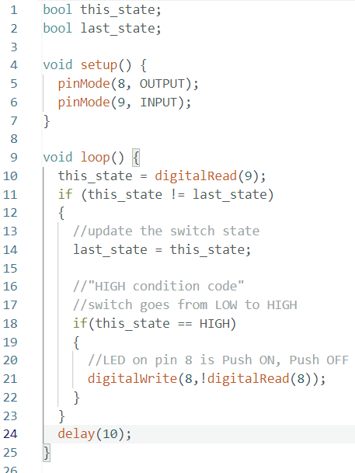

Questions

* 3a: What is the difference between pinMode(PIN, INPUT) and pinMode(PIN, INPUT PULLUP)?

Both commands sets the pin to input, but the input pullup sets the input to high if nothing else is connected to the input.

* 3b: How often do your program check if the button has been pushed? Does this seem reasonable?

Every 10ms, this is reasonable since it doesn’t use any unnecessary resources and is still fast enough to detect every button push.

* 3c: What is the operator ! used for?

Logical NOT results in a true if the operand is false and vice versa.